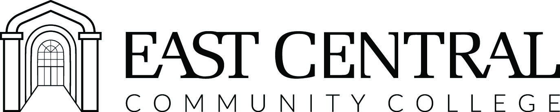

Practical Nursing Program

Practical Nursing offers a rewarding career as a Licensed Practical Nurse (LPN) in a profession that is highly valued and respected. The program is designed to educate students to meet the challenges of an exciting and dynamic career in nursing.  Upon completion of the program, the graduate of the Practical Nursing Program is prepared to assist in providing general nursing care in a variety of health care settings.  Admission Requirements:  - Apply for regular admission or readmission and be accepted by the college.  - Submit a completed application for the Practical Nursing program to the Office of Healthcare Education in the Phil A. Sutphin Hall.  - Must be at least eighteen (18) years of age.  - High School Diploma, GED, or equivalent.  - An ACT composite score of 16 (after October 1989).  - A HESI A2 with Critical Thinking  Pre-Admission Examination and score in the minimum percentile of 51 or above.  - Prerequisites of Anatomy and Physiology I and II with labs (or upper-level equivalents with labs) with a grade of “C” or higher.  - Satisfactory criminal history background check with approval.  - Proof of immunizations.  - Satisfactory physical examination  Fall Admission: Applications are accepted from January until March 31st of each year. | Scholarships and Financial Aid:  Financial assistance, which may include Pell Grants®, College Work Study, scholarships and loans are available to qualified East Central Community College Students. For more information contact the Office of Financial Aid at 1-877-462-3222, extension 218.  Faculty:  Highly qualified faculty are dedicated to the mission of the college in preparing students to meet national and state agency competencies and preparation for students to write the National Council Licensure Examination for Practical Nurses  (NCLEX-PN®) examination.  Health Care Alliances:  A variety of rotations are used to enhance students’ knowledge, skills, and abilities throughout the one year program.  Where do I begin:  Visit our website at https://www.eccc.edu/practical-nursing-pn  East Central Community College’s Practical Nursing Program is accredited by Mississippi State Board of Community and Junior Colleges at 3825 Ridgewood Road, Jackson, MS 39211. http://www.sbcjc.cc.ms.us/workforce  Edu/divdefault.aspx
Meeting minimum admission requirements does not guarantee admission to the program. Admission is based upon academic record and space availability. When the number of applicants who meet minimum requirements exceed the number of available spaces, the most-qualified applicants will be selected for admission using the points category for ranking.

Points Category
1. Within the five county ECCC district or previously enrolled at ECCC= 1 point  2. ACT | 3. GPA: College or High School  4. Pre-entrance Exam Score | 5. Each required science course (A&P I & A&P II) completed with an A=3 points, B=2 points, C=1 point.
  ACT composite score | Points
  16-18 | 1
  19-21 | 2
  22-24 | 3
  25 & above | 4
  GPA | Points
  2.0-2.9 | 1
  3.0-3.9 | 2
  4.0 | 3
  Pre-entrance Exam Cumulative Score | Points
  51% - 60% | 1
  61% - 70% | 2
  71% - 80% | 3
  80% or Above | 4
  Sciences completed with labs. | Points
  A&P I with lab
  A&P II with lab

Practical Nursing Program of Study

Academic Calendar | Course | Credit Hours
Fall | PNV 1115: Practical Nursing Foundations  PNV 1310: Professional Development | 15.00  0.00  Total: 15.00
Spring | PNV 1216: Intermediate Practical Nursing (FS)  PNV 1241: NCLEX® Review Course  PNV 1310: Professional Development | 16.00  1.00  0.00  Total: 17.00
Summer | PNV 1412: Advanced Practical Nursing (FS)  PNV 1310: Professional Development | 12.00  1.00  Total: 13.00

Enrollment in PNV courses is limited to students who have been admitted to the Practical Nursing program and these courses must be taken in the sequence specified. All nursing courses must be completed within one year to graduate from the Practical Nursing program.

Progression/Graduation Requirements: Average of 80 or above, grade of “C” or better on all nursing and required courses, mastery of selected nursing skills, and satisfactory completion of all program clinical rotations. Upon successful completion of the practical nursing program of study, graduates will be awarded 53 credit hours.

We appreciate your interest in our program and look forward to hearing from you. If you have any questions or wish to make an appointment to discuss the program contact the Office of Healthcare Education, by calling 601-635-6293.

